Does Variability in Defensive Pass Coverage Schemes Lead to Successful Pass Defense?

Peter Chapman
The University of Delaware
November 10th, 2025
SPAX402: Predictive Analysis with Athletics Data
National Football League

Introduction and Research Question
Through the first nine weeks of the 2025 National Football League (NFL) season, the Dallas Cowboys have utilized a large majority of zone coverage for their pass defense strategy. Subsequently, this means that the Cowboys have played very little man coverage during the opposing team’s passing plays. This complete dedication to one coverage strategy of pass defense begs a natural research question: does high variability in the use of the major defensive pass coverage schemes correlate to better performances in key pass defense metrics?
Standardized Entropy
The first part of the analysis will be determining each team’s variability in the use of the major defensive pass coverage schemes. The equation below shows the formula for standardized entropy, which will be used to calculate the variability for each NFL pass defense.
$$\begin{aligned}{CoverageStandardizedEntropy}_{Team, Year}=\frac{\left|Man\%*\ln\left(Man\%\right)+Zone\%*\ln\left(Zone\%\right)\right|}{\ln\left(2\right)}\end{aligned}$$
This calculation of standardized entropy considers just man and zone coverage as the two different pass coverage options that defenses have at their disposal. The number of defensive pass coverage options used in this standardized entropy calculation will depend on the availability of data.
Multiple Linear Regression Model
The standardized entropy variable, which is the predictor variable of interest, can be included in a multiple linear regression model to calculate the effect of defensive pass coverage variability on a significant pass defense outcome. The equation below shows this multiple linear regression model. Control variables such as average team pass rusher grade, average team corner grade, average team safety grade, and the average age of a team’s defense will be included in the model in order to isolate the effect of defensive pass coverage variability on the pass defense outcome. This dependent variable will most likely be expected points added per dropback, but it is dependent on the availability of data.
$${PassDefenseOutcome}_{Team,Year}={β_{0}+β_{1}CoverageStandardizedEntropy}_{Team, Year}+β_{2}{averageSafetyGrade}_{Team, Last 2 Years}+β_{3}{averageCornerGrade}_{Team, Last 2 Years}+β_{4}{averagePassRusherGrade}_{Team, Last 2 Years}+{β_{5}averageDefenderAge}_{Team, Year}+ε_{Team, Year}$$

Identified Data Sources
Figure 1 below shows the league-wide usage of the significant defensive pass coverage schemes during the first nine weeks of 2025. The table comes from ‘fball_insights’ on X, who sourced the data from the Fantasy Points Data Suite and the nflfastR package in R programming. There are seven major defensive pass coverage schemes across two main coverage types: zone coverage and man coverage. The ideal dependent variable, expected points added per dropback, is included in the table as well.
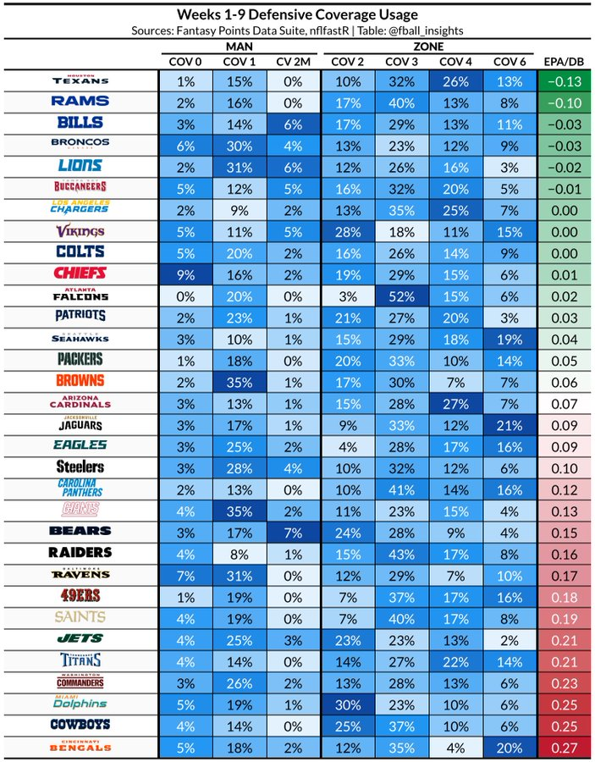
Figure 1: League-wide distribution of defensive pass coverage schemes across the first nine weeks of 2025. Generated by fball_insights on X.
Data will still need to be found for the control variables: average defender age, average team pass rusher grade, average team corner grade, and average team safety grade. These grades should be available from Pro Football Focus. The average defender age may require more research into the NFL’s league database online.
Expected Challenges
There will most likely be a few significant challenges within this project. First, data is difficult to find regarding the league-wide distribution of defensive pass coverage schemes across multiple seasons. The data found so far is just from the first nine weeks of the 2025 season, which does not provide a lot of data for potential clinical significance. A multiple linear regression with a small sample of data will have a very high variance, which limits predicting ability.
In a similar way, data extraction from the online Pro Football Focus database is quite difficult. In order to obtain the PFF grades for a team’s pass rushers, safeties, and cornerbacks in a given season, access to a paid PFF account must be gained.

